Online Assignment-1

Course Code: | CAP 276 |  | Course Title: | Data Communication and Networking-Laboratory
Course Instructor: Avinash Bhagat
Student’s Roll no: |  | RD2112B81 |  | Student’s Reg. no: |  | 12108348
Name: Aniket Kumar
Set Assigned (Tick): |  | B |  | Page No. | 1 | Total Pages | 3

- Objective:
Design a network topology with a star backbone connected to bus, ring and mesh topologies.

- Network Snapshot with proper labelling:

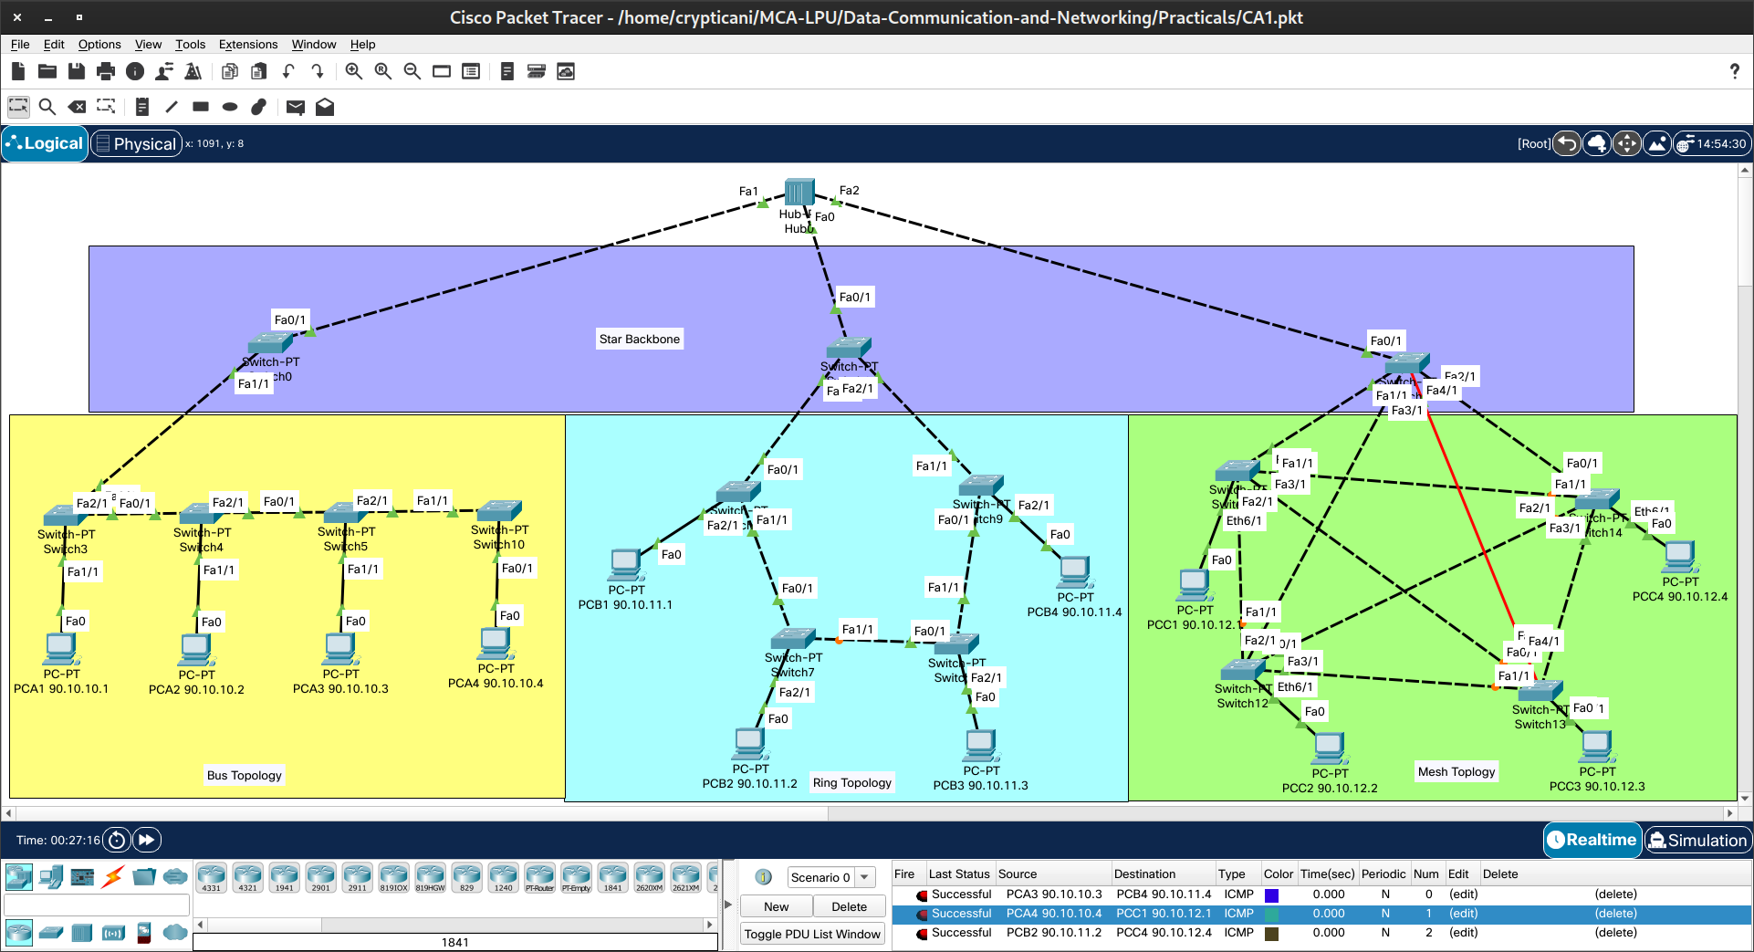

Course Code: | CAP 276 |  | Course Title: | Data Communication and Networking-Laboratory
Course Instructor: Avinash Bhagat
Student’s Roll no: |  | RD2112B81 |  | Student’s Reg. no: |  | 12108348
Name: Aniket Kumar
Set Assigned (Tick): |  | B |  | Page No. | 2 | Total Pages | 3

- Initial IP Configuration:
Device | Interface | IP Configuration | Connected with
PCA1 | Fa0 | 90.10.10.1 | Switch3
PCA2 | Fa0 | 90.10.10.2 | Switch4
PCA3 | Fa0 | 90.10.10.3 | Switch5
PCA4 | Fa0 | 90.10.10.4 | Switch10
PCB1 | Fa0 | 90.10.11.1 | Switch6
PCB2 | Fa0 | 90.10.11.2 | Switch7
PCB3 | Fa0 | 90.10.11.3 | Switch8
PCB4 | Fa0 | 90.10.11.4 | Switch9
PCC1 | Fa0 | 90.10.12.1 | Switch11
PCC2 | Fa0 | 90.10.12.2 | Switch12
PCC3 | Fa0 | 90.10.12.3 | Switch13
PCC4 | Fa0 | 90.10.12.4 | Switch14
Switch0 | Fa0/1 | ----- | Hub0
Switch0 | Fa1/1 | ----- | Switch3
Switch1 | Fa0/1 | ----- | Hub0
Switch1 | Fa1/1 | ----- | Switch6
Switch1 | Fa2/1 | ----- | Switch9
Switch2 | Fa0/1 | ----- | Hub0
Switch2 | Fa1/1 | ----- | Switch11
Switch2 | Fa2/1 | ----- | Switch14
Switch2 | Fa3/1 | ----- | Switch12
Switch2 | Fa4/1 | ----- | Switch13
Hub0 | Fa0 | ----- | Switch1
Hub0 | Fa1 | ----- | Switch0
Hub0 | Fa2 | ----- | Switch2

Course Code: | CAP 276 |  | Course Title: | Data Communication and Networking-Laboratory
Course Instructor: Avinash Bhagat
Student’s Roll no: |  | RD2112B81 |  | Student’s Reg. no: |  | 12108348
Name: Aniket Kumar
Set Assigned (Tick): |  | B |  | Page No. | 3 | Total Pages | 3

- Process Description:

Creating the Network:
Step-1: First of all, take a hub which is going to be main backbone of the network.
Step-2: Take 3 switches, namely Switch0, Switch1, Switch2 and connect it to the hub in star topology.
Step-3: For Bus Topology, Take 4 switches and 4 PCs and connect 1 PC to each Switch and each switch in a sequence to form a Bus topology.
Step-4: Connect first switch of Bus topology to Switch0.
Step-5: For Ring Topology, Take 4 switches and 4 PCs and connect 1 PC to each Switch and each switch in a sequence.
Step-6: Connect first switch and last switch to Switch1 to form a ring, so that, it becomes a Ring topology.
Step-7: For Mesh Topology, Take 4 switches and 4 PCs and connect 1 PC to each Switch and each switch to every other 3 switches.
Step-8: Connect Switch2 with all 4 switches of this network, so that it will become a Mesh topology.
Step-9: Finally, the network is created. Now wait for some time, so that the network becomes active by learning the paths.

Assigning the IP address:
Step-1: Click on the PC.
Step-2: Go to Desktop → IP configuration.
Step-3: Enter IPv4 address and Subnet mask of the class of IP the address.

Transferring the Packets:
Step-1: From toolbar, select “Add Simple PDU (P)”.
Step-2: Select source and destination PCs to transfer.
Step-3: Select a protocol, for example, ICMP.

